Transocean Site Implementation Specification

Transocean Site Implementation Specification 1

Version History 4

Access Information 4

How To Read This Document 5

Definitions 5

Schema Mapping Example 5

Schema – Detail Page 6

Site Implementation Overview 7

Pagetypes 7

Site Wide Conventions 8

Notes and Requirements 8

Schema – Site Control 9

Schema – Section Control 9

Site Functional Requirements 9

XHTML Compliance and Cross-Browser Compatibility 9

Application Functionality 9

Search Engine Optimization 10

Metadata 10

Page Title 10

Search 10

URLs 10

Site Features 11

Integration of Thomson Reuters Feeds 11

Thomson I-frame Integration 11

Home 12

Design 12

Notes & Requirements 12

Schema – Home 13

Career Center home 15

Design 15

Notes & Requirements 15

Schema – Career Center Home Page 16

Right Column Narrow Icon/Link Component 17

Right Column Alert Component 17

Video Detail Page 18

Notes and Requirements 18

Schema – Detail Page 18

Detail Page with Optional Right Column 20

Design 20

Notes & Requirements 20

Schema – Detail Page 21

Profile Video Listing Page 22

Design 22

Notes & Requirements 22

Schema – Profile Video Listing Page 23

Management Profile Page 24

Design 24

Notes & Requirements 24

Schema – Management Profile Listing Page 25

Job Search Page 26

Design 26

Notes & Requirements 26

Schema – Job Search Page 27

Rig Listing Page 28

Design 28

Notes & Requirements 28

Schema – Rig Listing Page 29

Video Listing Page 30

Design 30

Notes & Requirements 30

Schema – Video Listing Page 31

Equipment Page 32

Design 32

Notes & Requirements 32

Schema – Equipment Page 33

I-Frame Page 34

Design 34

Notes & Requirements 34

Schema – I-Frame Page 35

Search Results Page 36

Design 36

Notes and Requirements 36

Schema – Search Results Page 37

Rig Locator 38

Design 38

Notes & Requirements 38

Schema – Rig Locator Page 39

Rig Country Pop-up Component 40

Rig Country Pop-up Component 40

Rig Information Pop-Up Component 42

Notes and Requirements 42

Schema: Rig Location Component Pop-Up 43

Featured Rig Component 43

Components 45

Link Component 45

Schema – Link Component 45

Right Column Dual Link Component 45

Schema – Right Column Dual Link Component 45

Right Column Video Component 45

Schema – Video Component 45

Right Column Flex Component 45

Schema – Right Column Flex Component 45

Right Column Link List Component 45

Schema – Right Column Link List Component 45

Bio Video Component 46

Schema – Bio Video Component 46

Schema – Profile Component 46

Video Listing Component 46

Schema –Video Listing Component 46

Equipment Component 46

Schema – Equipment Component 46

Career Center Featured Image 47

Schema – Career Center Featured Image 47

Career Center Promo 47

Schema – Career Center Promo 47

# Version History

January 17, 2013 Draft for Internal Review

January 22, 2013 Draft for Client Review

January 23, 2013 Updates from Client Review

January 30, 2013 Updates from final client review

# Access Information

Design Templates: Provided by Herring Design

Site Implementation Project site: TBD

User: TBD

Pass: TBD

# How To Read This Document

## Definitions

**Template:** See Page Type below.

**Page Type:** Page Types are the functional equivalent of templates in the Ingeniux CMS. They define the various content types that can be displayed on any given page in your site. Because Ingeniux is an XML-based system, the content itself is separate from the display, and any given content type has the potential to be displayed in multiple ways – on a web browser, a mobile device, or even rendered as a PDF file. Because of this, page types in Ingeniux CMS are very flexible, and one page type can often handle a number of different display requirements.

**Component:** Components are pieces of reusable content that are inserted into pages. For example, making an advertisement a component and inserting it into various pages designed for it will allow that same ad to appear throughout the site. This allows you to change content in one place, and have the result broadcast throughout the rest of your site where it is used.

**Schema:** A schema defines what elements on a defined page type or component are exposed in the CMS so they can be modified by the user. Each field described will be rendered on the Edit Form in the Ingeniux CMS.

**Yellow Highlights:** Items highlighted in yellow are open questions addressed to you (the customer) that need to be answered as we proceed.

**Teal Highlights:** Items highlighted in teal are comments addressed internally for Ingeniux developers, usually referring to specific ways to implement the features of the site. These will be removed from the final draft of the specification.

## Schema Mapping Example

The example below shows how a schema for a Page Type or Component in this specification will map to the Edit Form of the Ingeniux CMS. Each row in the table defines each field in the page. The columns are defined as follows:

**Label:** Lists what the title of the field is on the Edit Form.

**Element Type:** Lists which element type will be used to store the content.

**Notes:** Any extra information about the element and its function.

**Req’d:** Notes whether the field is required or not.

**H/RO:** This notes whether the field is Hidden and Read Only. If a field is Hidden, only Administrators can see the element on the Edit Form. If a field is Read Only, the field will be visible, but grayed out and unable to be modified.

The table below is how the schema is defined in this specification:

### Schema – Detail Page

|  |  |  |  |  |  |
| --- | --- | --- | --- | --- | --- |
| Label | Element Type | Notes | Help Text | Req’d | H / RO |
| Title | Text |  |  | Y |  |
| SubTitle | Text |  |  |  |  |
| Abstract | Text |  |  | Y |  |
| Main Content Area | XHTML | Optional body copy content |  |  |  |
| Image | Component |  |  |  |  |
| Ancestor Nav | Navigation |  |  |  | H/RO |
| Site Control | Component | Banner and Footer |  |  | H/RO |

Which will look like this in the Ingeniux CMS:

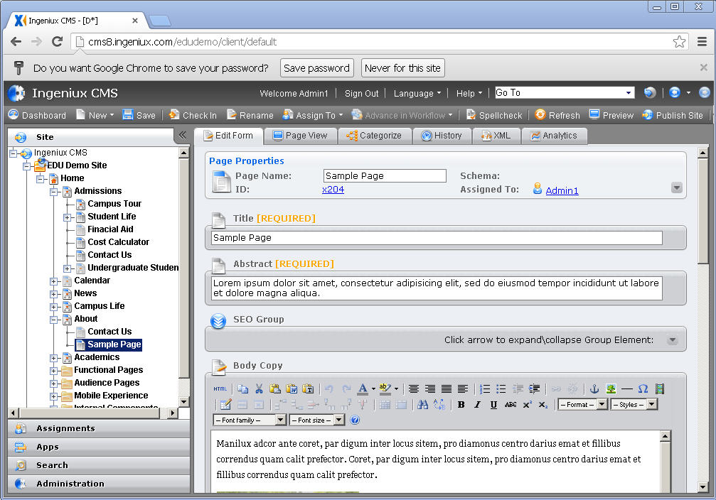

# Site Implementation Overview

This section defines the site implementation scope of work and requirements for Transocean (deepwater.com) Site implementation will consist of:

* Creation of up to 12 Page Types in Ingeniux CMS. The initial scope of work defined the following page requirements:
* Integration of Stock Information from Thomson Reuters for 2 pagetypes (Home and I-frame Page)
* Components as required to complete the specified Page Types.
* Structuring of permissions and workflow rules for site contributors (as part of 8 hrs of training consulting).

**Page Types** required for this site implementation include:

### Pagetypes

1. Home
2. Career Center Home
3. Detail Page w/Optional Right Column
4. Profile Video Page
5. Management Profile Page
6. Job Search Page
7. Rig Listing Page
8. Video Listing Page
9. Equipment Page
10. I-Frame Page
11. Search Results Page
12. Rig Finder
13. Video Detail Page

# Site Wide Conventions

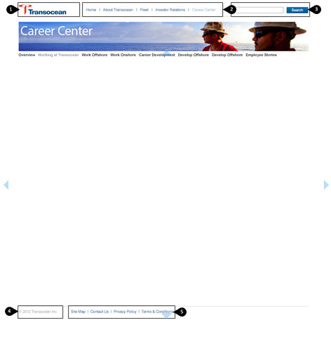

### Notes and Requirements

1. Logo: Linkable logo takes you to the home page; image element
2. Main Section Navigation: Navigation of the parent pages in the site, children appear as dropdown menus. Transocean should keep in mind design conventions when adding parent pages.

* Top level of the navigation will not be linkable. On the desktop the upon hover the children will show and the user will select the page they would like to go to and on tablet touching the top level will expand the children of that section.
* Top level navigation items (About Transocean, Fleet, etc.) will be created as a “page” with a text element for the top navigation title. There will be redirects that will be set by the client to either the homepage or an overview page.

1. Search Box: Ingeniux will implement Google search functionality
2. Copyright – text element for editability.
3. Utility Links – This will function using a link list. Transocean can add as many links as needed keeping in mind design convention.

### Schema – Site Control

|  |  |  |  |  |  |
| --- | --- | --- | --- | --- | --- |
| Label | Element Type | Notes | Help Text | Req’d | H / RO |
| Logo | Image |  |  | Y |  |
| Logo Link | Link |  |  | Y |  |
| Homepage Link | Link |  |  | Y |  |
| Main Section Navigation | Navigation |  |  | Y |  |
| Search Results Page | Link | Ingeniux Google Search |  | Y |  |
| Copyright | Text |  |  | Y |  |
| Footer Links | Link List |  |  |  |  |

### Schema – Section Control

|  |  |  |  |  |  |
| --- | --- | --- | --- | --- | --- |
| Label | Element Type | Notes | Help Text | Req’d | H / RO |
| Rotating Banner Image | Image List |  | Picking only one component will create a static image in this area | Y |  |
| Top Nav Red Button Link | Link | Used for Job Search, could also be used in other sections if desired |  |  |  |
| Site Control | Component |  |  | Y |  |

## Site Functional Requirements

### XHTML Compliance and Cross-Browser Compatibility

* Ingeniux will use W3C-standard XHTML that meets accessibility compliance requirements.
* Ingeniux will provide cross-browser display for Firefox PC and Mac latest version, IE 8 & 9 Windows, Chrome latest version and Safari latest version.
* Alt-text shall be used for all images throughout the site.

### Application Functionality

* Google Search functionality
* Styles to be added to the WYSIWYG editor: <http://to.friedbyte.com/element-list.html>

## Search Engine Optimization

The SEO Group will consist of the following fields. Note: all fields will be hidden with the exception of Keywords, Meta Description, and Browser Bar Title. Those fields mentioned will be accessible to all user groups. The hidden fields marked below will only be accessible to admin users

|  |  |  |  |  |
| --- | --- | --- | --- | --- |
| **Label** | **Element Type** | **Notes** | **Req'd** | **H/RO** |
| SEO Group | group start |  |  |  |
| Browser Bar Title | text |  |  |  |
| Meta Description | text |  |  |  |
| Meta Keywords | text |  |  |  |
| Navigation Name | Text |  |  | H/RO |
| Site Map Priority | enumeration | **Choices:** .9;.8;.7;.6;.5;.4;.3;.2;.1 |  | H/RO |
| No Follow | checkbox |  |  | H/RO |
| No Index | checkbox |  |  | H/RO |
| No ODP | checkbox |  |  | H/RO |
|  | group end |  |  |  |

### Metadata

Metadata descriptions for search engines are typically taken from the “Abstract” field in the page schema. This can be modified to conform to general site-wide standards for population of search engine metadata fields.

### Page Title

The “Page Title” field will be used by default to populate the browser window / tab title

### Search

Site search will use the Google Mini application. Integration with Google Mini will be done by Ingeniux.

### URLs

Published pages will use Structured URLs in lowercase format separated by underscores and without file extensions Note that the underscore separator will be used to ease in the transition to the new CMS system.

# **Site Features**

## Integration of Thomson Reuters Feeds

Thomson needs to authorize the Ingeniux IP address to access the feeds listed below. News, Stock Information, and Disclaimer info (once an updated design is provided) will pull in via XML feed to show on the home page.

Developer Manual:

<http://media.corporate-ir.net/media_files/irol/21/218273/intranet/developer%20manuals/manual_NewsReleases.doc>

Stock Quote Developer Manual:

<http://media.corporate-ir.net/media_files/irol/21/218273/intranet/developer%20manuals/manual_Quotes.doc>

Stock Quote XML feed:

<http://xml.corporate-ir.net/irxmlclient.asp?compid=113031&reqtype=QUOTES>

News Releases List XML:

<http://xml.corporate-ir.net/irxmlclient.asp?compid=113031&reqtype=NEWSRELEASES> (sorted by category first, then date; may contain multiple instances of the same releases if categorized twice)

<http://xml.corporate-ir.net/irxmlclient.asp?compid=113031&reqtype=NEWSRELEASES_2> (sorted by date)

## Thomson I-frame Integration

Ingeniux will create an I-frame page that will pull in information provided by Thomson Reuters. All of the information aside from the head and footer on the I-frame pages will be pulled in via I-frame. Ingeniux will provide an optional Page title field for this page.

## Home

### Design

### Notes & Requirements

1. Rotating Banner Image – An Image listing element will be provided to set the rotating images for the home page of the site. If only one image is selected the banner will remain stationary.
2. Site Navigation – Main site navigation showing 4 parent pages with dropdown menus to show their children. The design does not account for showing more than 4 sections in the header area. Making changes to the text styling shown here is not managed in the CMS and will require someone to change the style within the CSS.
3. Left Column Copy – This will be an open XHTML copy area accepting text, links, or images.
4. Fleet Reports – Document listing of fleet documents. This will be a manually selected link list.
5. News Listing – News stories will be pulled in via a Thomson Reuters feed. See out line under Site Features area.
6. Search Box: Ingeniux will implement Google search functionality
7. Stock Quote – Stock quote information will be pulled in via a Thomson Rueters feed; see outline under Site Features area.
8. Featured Rig – There will be an image and text element for the featured rig image and title. The Rig Information will be pulled in from an excel spreadsheet which has been uploaded to the CMS. The categories shown in the bullet points below along their associated information will be pulled into this “Featured Rig” area on the home page as well as the area referenced on the map shown later in this document. The featured rig shown will rotate on page refresh and will rotate through all rigs within the uploaded excel document. When Transocean makes changes or adds/deletes rigs they will need to upload a new excel document for the changes to be reflected in the site:

* Rig Type
* Name
* Yr Entered Service
* Water Depth (feet)
* Drilling Depth (feet)
* Location

### Schema – Home

|  |  |  |  |  |  |
| --- | --- | --- | --- | --- | --- |
| Label | Element Type | Notes | Help Text | Req’d | H / RO |
| Page Title | Text |  |  | Y |  |
| Home Image Listing (940 x 100) | Image List |  |  | Y |  |
| Left Column Copy | XHTML |  |  |  |  |
| Fleet Report Header | Text |  |  |  |  |
| Fleet Report Listing | Link List |  |  |  |  |
| News Header | Text |  |  |  |  |
| News Feed | Text | XML feed from Thomson |  |  |  |
| Stock Quote Feed | Text | XML feed from Thomson |  |  |  |
| Featured Rigs | List |  |  |  |  |
| SEO Group | Group |  |  | Y |  |
| Ancestor Navigation | Navigation |  |  | Y |  |
| Section Control | Component |  |  | Y | H / RO |

## Career Center home

### Design

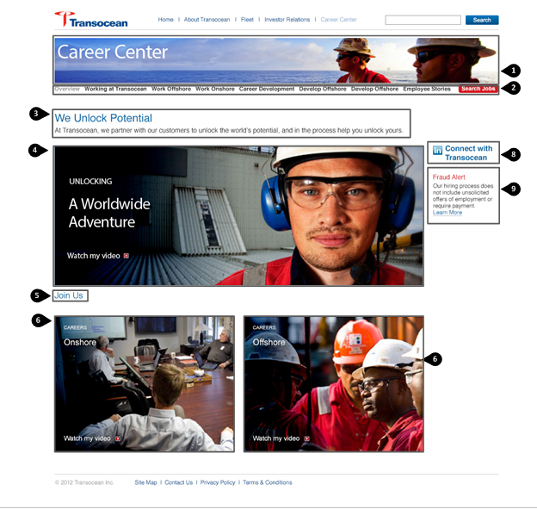

### Notes & Requirements

1. Rotating Banner Image – An Image listing element managed in the section control will be provided to set the rotating images for each section of the site. If only one image is selected the banner will remain stationary.
2. Subnavigation – This will populate the child pages of the current section a user is in. The number of children than can display is constrained by the design. If more child pages are entered than there is room for it may break the design or not show all pages. Making changes to the text styling shown here is not managed in the CMS and will require someone to change the style within the CSS.
3. Page Title and Subtitle – These will be text elements with styling automatically applied.
4. Career Center Featured Image: Poster board (static image) that links to a video. This area will be managed with an image element, link element, and optional text boxes (Intro Header, Header, Link text). Videos are managed on IGX server; Transocean has currently 14 videos but will be adding more over time. Videos should be supplied as MP4 files. All videos will be played on Video Detail Pages.
5. Header – Text element with styling automatically applied
6. Onshore Video Image: Poster board for video; This area will be managed with an image element, link element, and optional text boxes (Intro Header, Header, Link text)
7. Offshore Video Image: Poster board for video; This area will be managed with an image element, link element, and optional text boxes (Intro Header, Header, Link text)
8. Right Column Narrow icon/link component– This component will consist link element and icon. These components will be dropped into the Right Column component list for this page and multiple of these components may be added by Transocean.
9. Right Column Narrow Alert Component – This component will consist of a Text Header and body copy area for fraud information and links or other alert information. These components will be dropped into the Right Column component list for this page and multiple of these components may be added by Transocean.

### Schema – Career Center Home Page

|  |  |  |  |  |  |
| --- | --- | --- | --- | --- | --- |
| Label | Element Type | Notes | Help Text | Req’d | H / RO |
| Page Title | Text | Won’t display on page |  | Y |  |
| Header | Text |  |  |  |  |
| Subtitle | Text |  |  |  |  |
| Body Copy | XHTML |  |  |  | RO |
| Careers Center Featured Image | Component |  |  |  |  |
| Join Us Header | Text |  |  |  |  |
| Career Center Promo Left | Component |  |  |  |  |
| Career Center Promo Right | Component |  |  |  |  |
| Right Column Narrow Components | Component List | CompType: Right column narrow alert component; Right Column narrow icon/link component |  |  |  |
| SEO Group | Group |  |  |  | H/RO |
| Ancestor Nav | Navigation |  |  |  | H/RO |
| Section Control | Component |  |  |  | H/RO |

### Right Column Narrow Icon/Link Component

|  |  |  |  |  |  |
| --- | --- | --- | --- | --- | --- |
| Right Column Icon | Image |  |  |  |  |
| Right Column Link | Link |  |  |  |  |

### Right Column Alert Component

|  |  |  |  |  |  |
| --- | --- | --- | --- | --- | --- |
| Right Column Alert Header | Text |  |  |  |  |
| Right Column Alert Copy | XHTML |  |  |  |  |

## Video Detail Page

## 

### Notes and Requirements

* All videos on the site will play on a video detail page.

### Schema – Detail Page

|  |  |  |  |  |  |
| --- | --- | --- | --- | --- | --- |
| Label | Element Type | Notes | Help Text | Req’d | H / RO |
| Page Title | Text | Will display on the page as the page title |  | Y |  |
| Body Copy | XHTML |  |  |  | RO |
| Video | Media Element |  |  | Y |  |
| Ancestor Navigation | Navigation |  |  |  | H/RO |
| SEO Group | Group |  |  |  | H/RO |
| Section Control | Component |  |  |  | H/RO |

## Detail Page with Optional Right Column

### Design

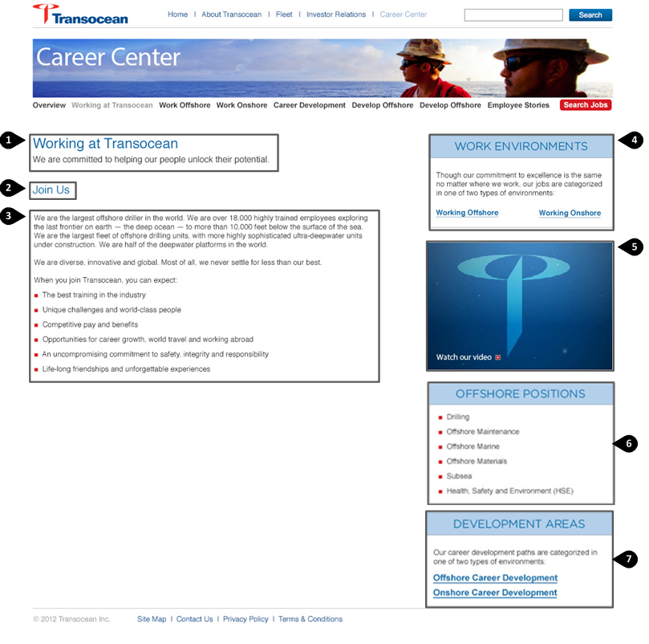

### Notes & Requirements

1. Page Title and Subtitle – These will be text elements with styling automatically applied.
2. Header – A text element with styling automatically applied
3. Body Copy – Open XHTML body copy are allowing text, links, and images.
4. Right Column Dual Link Component: This component will contain elements for a header (text), text, and a right and left link.
5. Right Column Video Component: This component will contain elements for an image, link.
6. Right Column Flex Component: This component will contain elements for header (text), and body copy
7. Right Column Link List Component: This component will contain elements for a header (text), text, and link list.

### Schema – Detail Page

|  |  |  |  |  |  |
| --- | --- | --- | --- | --- | --- |
| Label | Element Type | Notes | Help Text | Req’d | H / RO |
| Page Title | Text | Will display on the page as the page title |  | Y |  |
| Subtitle | Text |  |  |  |  |
| Header | Text |  |  |  |  |
| Body Copy | XHTML |  |  |  |  |
| Right Column Components | Component List | CompType:  Right Column Dual Link Component  Right Column Video Component  Right Column Flex Component  Right Column Link List Component  Bio Video |  |  |  |
| Ancestor Navigation | Navigation |  |  |  | H/RO |
| SEO Group | Group |  |  |  | H/RO |
| Section Control | Component |  |  |  | H/RO |

## Profile Video Listing Page

### Design

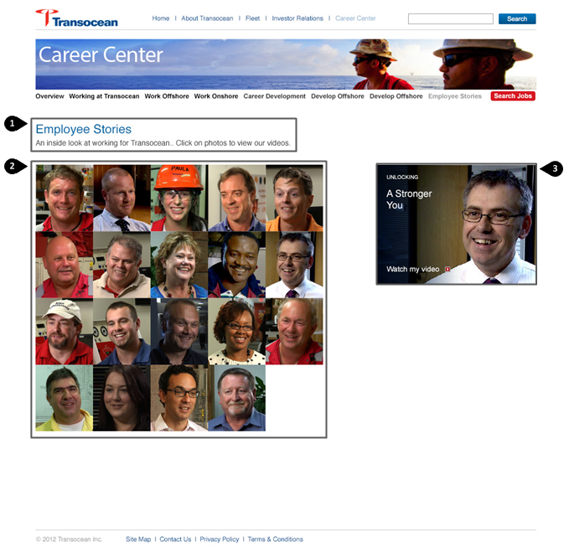

### Notes & Requirements

1. Page Title and Subtitle – These will be text elements with styling automatically applied.

* There will be the option for body copy beneath this area.

1. Video listing – Will use a component list to show video tiles.

* IGX Dev: When you first come to this page there are no videos showing to the right.

1. Bio Video Component - BioVideo component contains, image, thumbnail image (for the listing to the left), link, small header, text, Header and a dropdown to choose alignment to the right or left.

### Schema – Profile Video Listing Page

|  |  |  |  |  |  |
| --- | --- | --- | --- | --- | --- |
| Label | Element Type | Notes | Help Text | Req’d | H / RO |
| Page Title | Text | Will display on the page as the page title |  | Y |  |
| Subtitle | Text |  |  |  |  |
| Body Copy | XHTML |  |  |  | RO |
| Bio Video Listing | Component List | CompType: Bio Video |  |  |  |
| Ancestor Navigation | Navigation |  |  |  | H/RO |
| SEO Group | Group |  |  |  | H/RO |
| Section Control | Component |  |  |  | H/RO |

## Management Profile Page

### Design

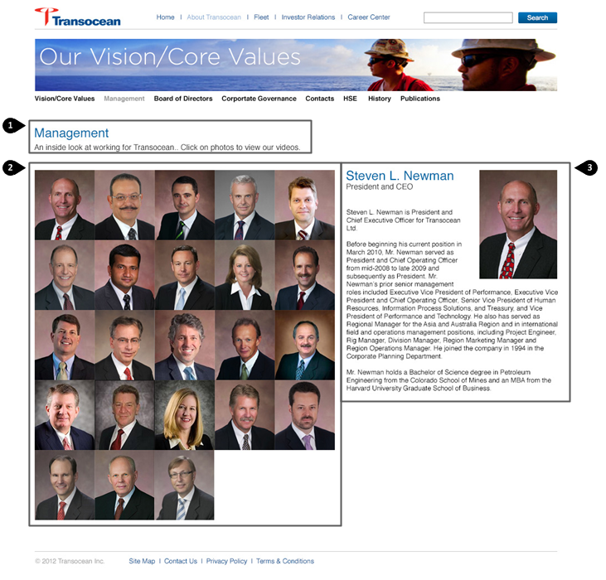

### Notes & Requirements

1. Page Title and Subtitle – These will be text elements with styling automatically applied.

* There will be an optional body copy section beneath this area.

1. Profile listing – Will us a component list to show management profiles. When clicking the separate profile images the profile component with associated information shows to the right.

* Clients Desired Print Functionality is to print the selected profile. Functionality for this page has been tested and found to be working as specified, however if during development it is discovered additional work is required this may be additional scope.

1. Profile Component – Contains elements for a Name (text), Job Title(Text), body copy, Featured image; thumbnail image.

* There will be a default component so Transocean can choose the profile they would like showing when they enter the page. If the component is empty no default will show on the page and the right column will be blank.

### Schema – Management Profile Listing Page

|  |  |  |  |  |  |
| --- | --- | --- | --- | --- | --- |
| Label | Element Type | Notes | Help Text | Req’d | H / RO |
| Page Title | Text | This will display as the page title |  | Y |  |
| Subtitle | Text |  |  |  |  |
| Body Copy | XHTML |  |  |  | RO |
| Default Profile | Profile component |  |  |  |  |
| Profile Listing | Component List | Comptype: Profile |  |  |  |
| Ancestor Navigation | Navigation |  |  |  | H/RO |
| SEO Group | Group |  |  |  | H/RO |
| Section Control | Component |  |  |  | H/RO |

## Job Search Page

### Design

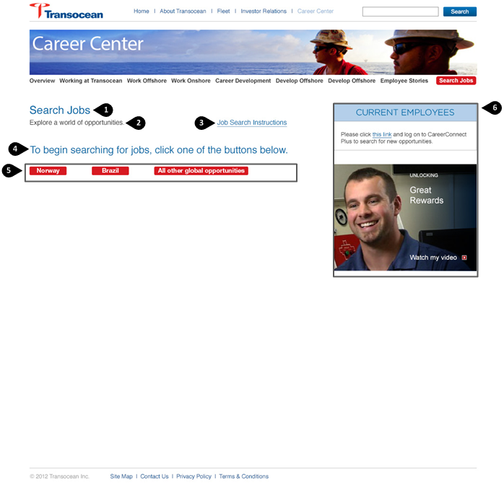

### Notes & Requirements

1. Page Title: This will be a text element with styling automatically applied.
2. Subtitle – This will be a text element with styling automatically applied

* There will be an optional body copy section beneath this area.

1. Job Search Link – This links externally to the job search page.
2. Heading - A text element with styling automatically applied
3. Job Search Links – External links to the job search pages
4. Right Column Component List – any right column components can be dropped in this area

### Schema – Job Search Page

|  |  |  |  |  |  |
| --- | --- | --- | --- | --- | --- |
| Label | Element Type | Notes | Help Text | Req’d | H / RO |
| Page Title | Text | Will display as the page title |  | Y |  |
| Subtitle | Text |  |  |  |  |
| Featured Image | Image |  |  |  |  |
| Job Search Instructions Link | Link |  |  |  |  |
| Body Copy | XHTML |  |  |  | RO |
| Heading | Text |  |  |  |  |
| Job Search Links | Link list |  |  |  |  |
| Right Column Component List | Component List | Comptype:  Right Column Dual Link Component  Right Column Video Component  Right Column Flex Component  Right Column Link List Component  Bio Video Component |  |  |  |
| Ancestor Navigation | Navigation |  |  |  | H/RO |
| SEO Group | Group |  |  |  | H/RO |
| Section Control | Component |  |  |  | H/RO |

## Rig Listing Page

### Design

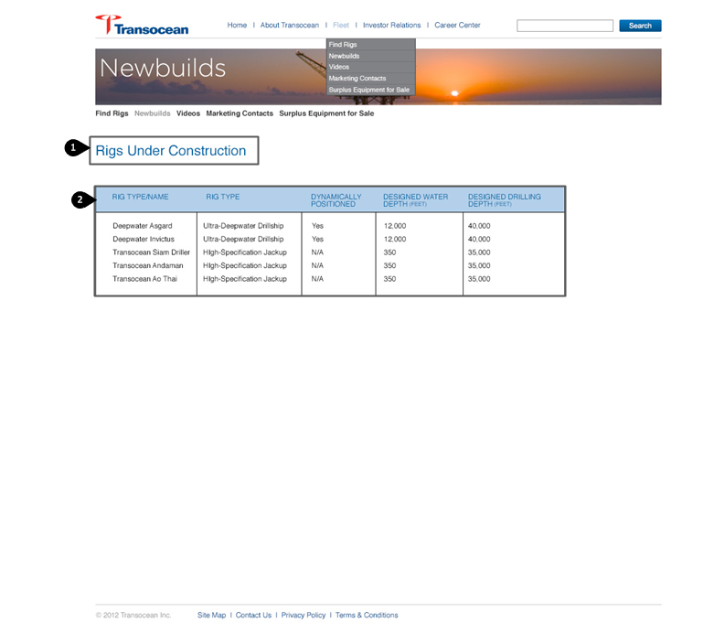

### Notes & Requirements

1. Page Title: This will be a text element with styling automatically applied.

* There will be an optional body copy section beneath this area.

1. Rig Table –The table will be managed in a separate body copy area. During training discuss Workflow options to constrain non-admin users from publishing changes to the table headers.

* There will be an optional lower body copy section beneath this area.

### Schema – Rig Listing Page

|  |  |  |  |  |  |
| --- | --- | --- | --- | --- | --- |
| Label | Element Type | Notes | Help Text | Req’d | H / RO |
| Page Title | Text | Will display at the title on the page |  |  |  |
| Header | Text |  |  |  |  |
| Upper Body Copy |  |  |  |  | RO |
| Table Copy | XHTML |  |  |  |  |
| Lower Body Copy | XHTML |  |  |  | RO |
| Ancestor Navigation | Navigation |  |  |  | H/ RO |
| SEO Group | Group |  |  |  | H/RO |
| Section Control | Component |  |  |  | H/ RO |

## Video Listing Page

### Design

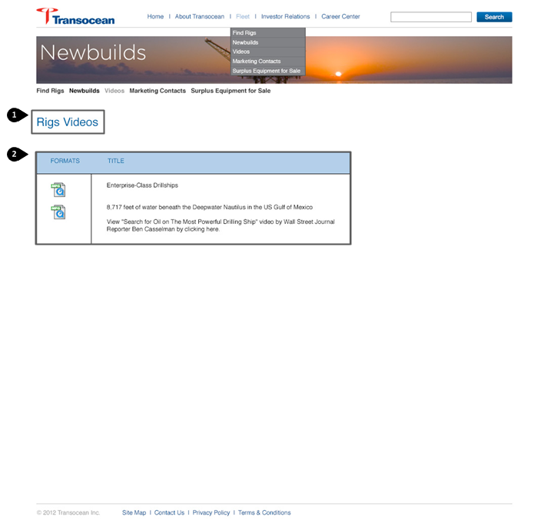

### Notes & Requirements

1. Page Title: This will be a text element with styling automatically applied.

* There will be an optional body copy section beneath this area.

1. Video Listing – This will be a video component list, video components will have an thumbnail icon, text title, and link to the Video Detail page.

### Schema – Video Listing Page

|  |  |  |  |  |  |
| --- | --- | --- | --- | --- | --- |
| Label | Element Type | Notes | Help Text | Req’d | H / RO |
| Page Title | Text | Will display as the title on the page |  |  |  |
| Body Copy | XHTML |  |  |  | RO |
| Table Header Column 1 | Text |  |  |  | RO |
| Table Header Column 2 | Text |  |  |  | RO |
| Video Listing | Component List | CompType: Video Component |  |  |  |
| Ancestor Navigation | Navigation |  |  |  | H/RO |
| SEO | Group |  |  |  | H/RO |
| Section Control | Component |  |  |  | H/RO |

## Equipment Page

### Design

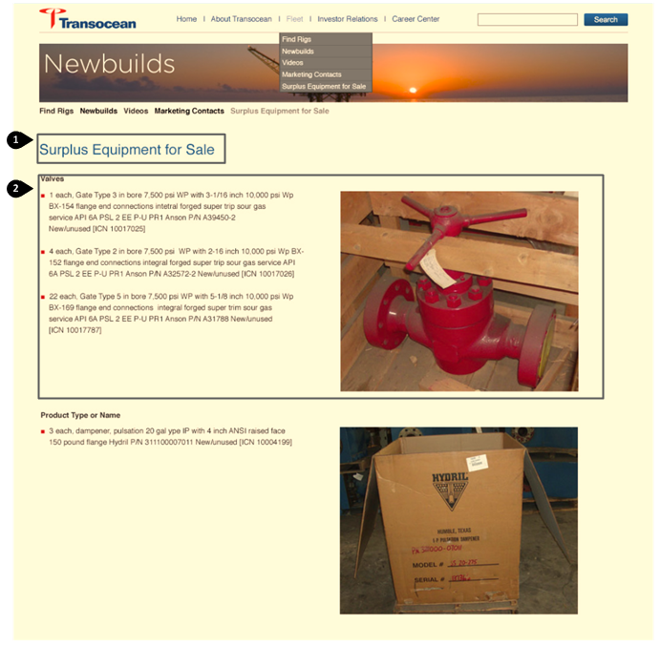

### Notes & Requirements

1. Page Title: This will be a text element with styling automatically applied.

* There will be an optional body copy section beneath this area.

1. Equipment Listing – This will function as a component list with Equipment Components. Equipment Components contain a Left aligned header, right aligned image, left aligned body copy

### Schema – Equipment Page

|  |  |  |  |  |  |
| --- | --- | --- | --- | --- | --- |
| Label | Element Type | Notes | Help Text | Req’d | H / RO |
| Page Title | Text | This will display as the page title |  |  |  |
| Body Copy | XHTML |  |  |  | RO |
| Equipment Listing | Component List | CompType: Equipment Component |  |  |  |
| Ancestor Nav | Navigation |  |  |  | H/RO |
| SEO Group | Group |  |  |  | H/RO |
| Section Control | Component |  |  |  | H/RO |

## I-Frame Page

### Design

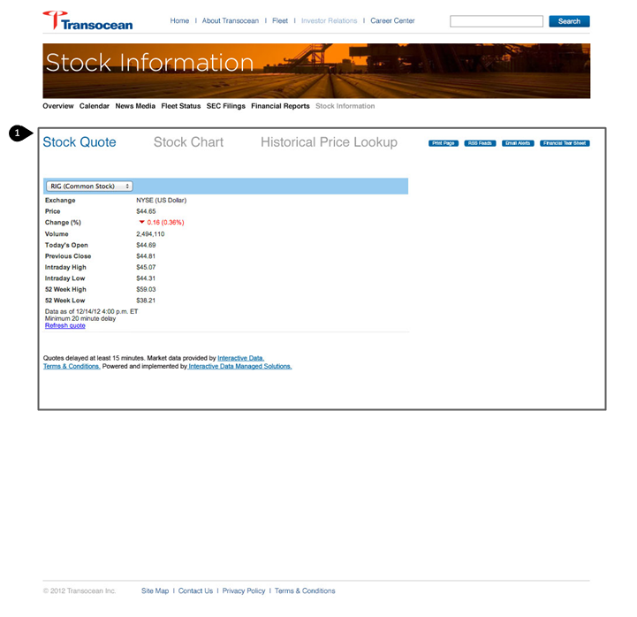

### Notes & Requirements

1. All center content for the page (everything aside from the header and footer) will be pulled in via I-frame and styled by Thomson Reuters.

### Schema – I-Frame Page

|  |  |  |  |  |  |
| --- | --- | --- | --- | --- | --- |
| Label | Element Type | Notes | Help Text | Req’d | H / RO |
| Page Title | Text |  |  | Y |  |
| Display Title on Page | Boolean | Checkbox to choose whether to display the title on the page; default to false |  |  |  |
| I-Frame URL | Text |  |  |  | RO |
| I-Frame width | Text |  |  |  | RO |
| I-Frame Height | Text |  |  |  | RO |
| SEO Group | Group |  |  |  | H/RO |
| Ancestor Nav | Navigation |  |  |  | H/RO |
| Section Control | Component |  |  | Y | H/RO |

## Search Results Page

### Design

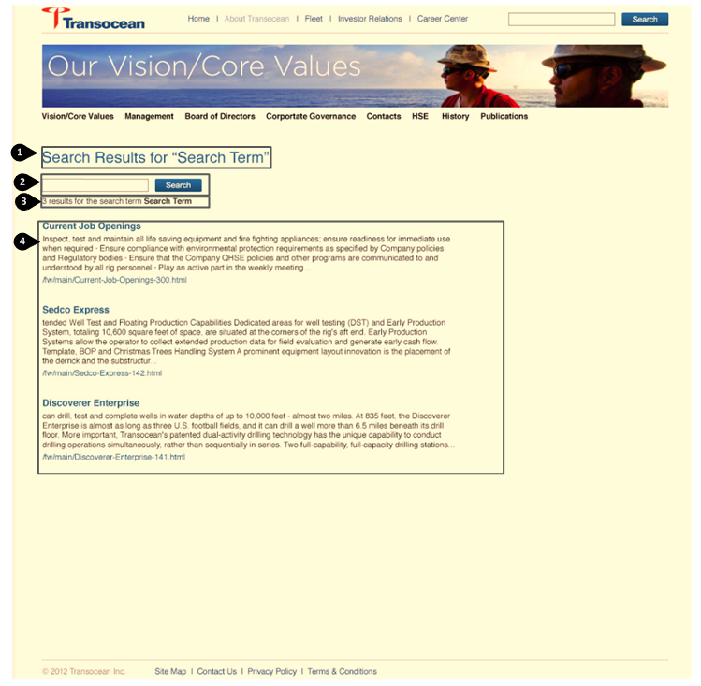

### Notes and Requirements

* Ingeniux will create a Google catalog for indexing the Thomson Reuters site in addition a to a Google catalog to index the Ingeniux hosted site. This will allow users on deepwater.com (Ingeniux hosted site) to search both Transocean and Thomson content. Thomson restricts site indexing from 8 am – 8pm EST, so during these hours no new content will be indexed.

1. Results Text is automatically populated based on the search term entered.
2. Search Bar functions the same as the search bar within the header and allows the user to search the site again if desired for a new search term.
3. Number of Results
4. Results Listing will automatically display as designed above

### Schema – Search Results Page

|  |  |  |  |  |  |
| --- | --- | --- | --- | --- | --- |
| Label | Element Type | Notes | Help Text | Req’d | H / RO |
| Page Title | Text |  |  |  |  |
| Search Results | Insert |  |  |  |  |
| SEO Group | Group |  |  |  | H/RO |
| Ancestor Nav | Navigation |  |  |  | H/RO |
| Section Control | Component |  |  | Y | H/RO |

## Rig Locator

### Design

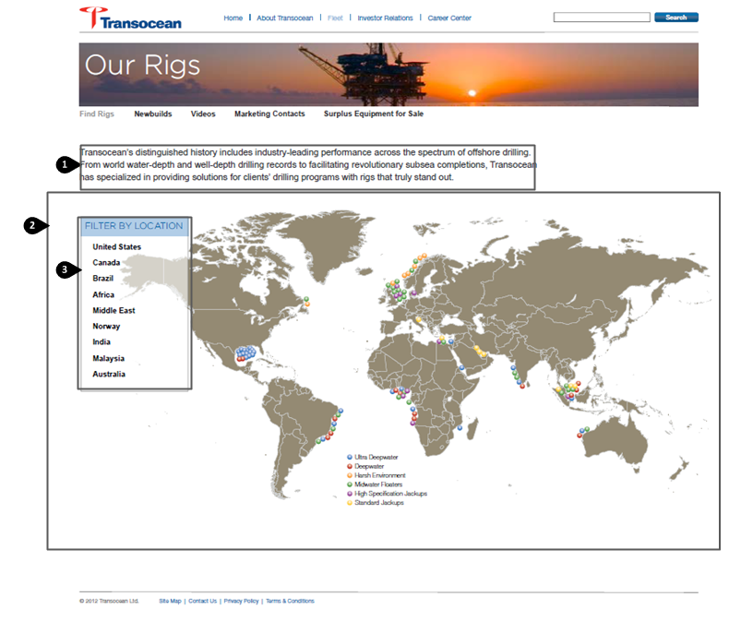

### Notes & Requirements

1. Intro Copy – optional body copy area to display above map display
2. Map Background Image – This area will be managed through a large background image.

* If changes are needed to the map image it will need to be edited outside of the CMS and upload a new map image.
* The map will not be interactive or linkable from within the image itself.

1. Filter by Location

* This area will have an editable text header. Beneath the header will be a list of the location by country. These country links will be manually selected and ordered through the selection of Rig Country Pop-Up Components. Each Rig Country Pop-up Component will provide all country details displayed overlaying this view if a country is clicked from the list. This list may be longer or shorter than the map image and Rig Information shown below and does not need to match exactly as shown in the design.

### Schema – Rig Locator Page

|  |  |  |  |  |  |
| --- | --- | --- | --- | --- | --- |
| Label | Element Type | Notes | Help Text | Req’d | H / RO |
| Title | Text |  |  |  |  |
| Intro Copy | Text |  |  |  |  |
| Background Map Image | Image |  |  |  |  |
| Location Header | Text |  |  |  |  |
| Location Listing | Component List |  |  |  |  |
| SEO Group | Group |  |  |  | H/RO |
| Ancestor Nav | Navigation |  |  |  | H/RO |
| Site Control | Component |  |  | Y | H/RO |

### Rig Country Pop-up Component

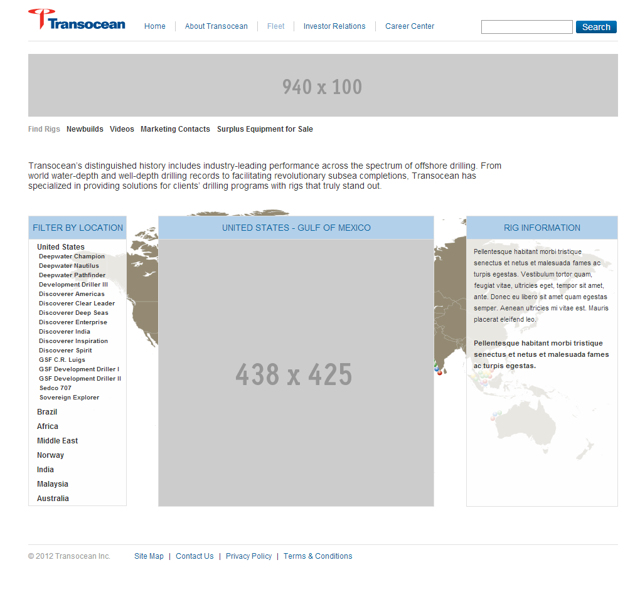

### Rig Country Pop-up Component

|  |  |  |  |  |  |
| --- | --- | --- | --- | --- | --- |
| Label | Element Type | Notes | Help Text | Req’d | H / RO |
| Country Location Header | Text |  |  |  |  |
| Country Locations Image | Image |  |  |  |  |
| Right Column Header | Text |  |  |  |  |
| Right Column Copy | XHTML |  |  |  |  |
| Location Header | Text |  |  |  |  |
| Rig Location Listing | Component List |  |  |  |  |
| SEO Group | Group |  |  |  | H/RO |
| Ancestor Nav | Navigation |  |  |  | H/RO |
| Site Control | Component |  |  | Y | H/RO |

### Rig Information Pop-Up Component

### Notes and Requirements

Rig information will be managed in components and dropped into a component list – The component will contain elements for a location (longitude and latitude), a link field for the PDF document, and a group containing optional text elements for rig labels and information which can be added manually. The fields below will be pulled in from an excel document which will be uploaded by Transocean to the CMS. When Transocean makes changes or adds/deletes rigs they will need to upload a new excel document for the changes to be reflected in the site:

* Rig Type/Name
* Yr Entered Service
* Water Depth (feet)
* Drilling Depth (feet)
* Location

### Schema: Rig Location Component Pop-Up

|  |  |  |  |  |  |
| --- | --- | --- | --- | --- | --- |
| Label | Element Type | Notes | Help Text | Req’d | H / RO |
| Location Header | Text |  |  |  |  |
| Location Image | Image |  |  |  |  |
| Rig Listing | Navigation |  |  |  |  |

### Featured Rig Component

|  |  |  |  |  |  |
| --- | --- | --- | --- | --- | --- |
| Rig Title | Text | Pulled from Excel Doc |  |  |  |
| Rig Image | Image |  |  |  |  |
| Rig Type/Name | Text | Pulled from Excel Doc |  |  |  |
| Yr Entered Service | Text | Pulled from Excel Doc |  |  |  |
| Water Depth (feet) | Text | Pulled from Excel Doc |  |  |  |
| Drilling Depth (feet) | Text | Pulled from Excel Doc |  |  |  |
| Location | Text | Pulled from Excel Doc |  |  |  |
| Field Name Group | Group Start |  |  |  |  |
| Field Label 1 | Text |  |  |  |  |
| Field Value 1 | Text |  |  |  |  |
| Field Label 2 | Text |  |  |  |  |
| Field Value 2 | Text |  |  |  |  |
| Field Label 3 | Text |  |  |  |  |
| Field Value 3 | Text |  |  |  |  |
| Field Label 4 | Text |  |  |  |  |
| Field Value 4 | Text |  |  |  |  |
| Field Label 5 | Text |  |  |  |  |
| Field Value 5 | Text |  |  |  |  |
| Field Label 6 | Text |  |  |  |  |
| Field Value 6 | Text |  |  |  |  |
| Field Label 7 | Text |  |  |  |  |
| Field Value 7 | Text |  |  |  |  |
| Field Label 8 | Text |  |  |  |  |
| Field Value 8 | Text |  |  |  |  |
| Field Label 9 | Text |  |  |  |  |
| Field Value 9 | Text |  |  |  |  |
| Field Label 10 | Text |  |  |  |  |
| Field Value 10 | Text |  |  |  |  |
| Group End | End |  |  |  |  |
| Latitude | Text |  | Used to populate Google map | Y |  |
| Longitude | Text |  | Used to populate Google map | Y |  |
| Link Thumbnail (24x24) | Image |  |  |  |  |
| Right Column Document Link | Link | For the PDF |  |  |  |

# Components

## Link Component

### Schema – Link Component

|  |  |  |  |  |  |
| --- | --- | --- | --- | --- | --- |
| Label | Element Type | Notes | Help Text | Req’d | H / RO |
| Link | link |  |  | Y |  |

## Right Column Dual Link Component

### Schema – Right Column Dual Link Component

|  |  |  |  |  |  |
| --- | --- | --- | --- | --- | --- |
| Label | Element Type | Notes | Help Text | Req’d | H / RO |
| Header | Text |  |  |  |  |
| Text | Text |  |  |  |  |
| Right Link | Link |  |  |  |  |
| Left Link | Link |  |  |  |  |

## Right Column Video Component

### Schema – Video Component

|  |  |  |  |  |  |
| --- | --- | --- | --- | --- | --- |
| Label | Element Type | Notes | Help Text | Req’d | H / RO |
| Image | Image |  |  | Y |  |
| Link | Link |  |  | Y |  |

## Right Column Flex Component

### Schema – Right Column Flex Component

|  |  |  |  |  |  |
| --- | --- | --- | --- | --- | --- |
| Label | Element Type | Notes | Help Text | Req’d | H / RO |
| Header | Text |  |  |  |  |
| Body Copy | XHTML |  |  |  |  |

## Right Column Link List Component

### Schema – Right Column Link List Component

|  |  |  |  |  |  |
| --- | --- | --- | --- | --- | --- |
| Label | Element Type | Notes | Help Text | Req’d | H / RO |
| Header | Text |  |  |  |  |
| Text | Text |  |  |  |  |
| Link List | Link List |  |  |  |  |

## Bio Video Component

### Schema – Bio Video Component

|  |  |  |  |  |  |
| --- | --- | --- | --- | --- | --- |
| Label | Element Type | Notes | Help Text | Req’d | H / RO |
| Header | Text |  |  |  |  |
| Image | Image |  |  | Y |  |
| Thumbnail Image | Image |  |  | Y |  |
| Link | Link |  |  | Y |  |
| Small Header | Text |  |  |  |  |
| Text Alignment (L/R) | Dropdown |  |  | Y |  |

### Schema – Profile Component

|  |  |  |  |  |  |
| --- | --- | --- | --- | --- | --- |
| Label | Element Type | Notes | Help Text | Req’d | H / RO |
| Name | Text |  |  | Y |  |
| Job Title | Text |  |  |  |  |
| Body Copy | XHTML |  |  |  |  |
| Featured Image | Image |  |  | Y |  |
| Thumbnail | Image |  |  | Y |  |

## Video Listing Component

### Schema –Video Listing Component

|  |  |  |  |  |  |
| --- | --- | --- | --- | --- | --- |
| Label | Element Type | Notes | Help Text | Req’d | H / RO |
| Thumbnail Icon | Image |  |  |  |  |
| Title | Text |  |  |  |  |
| Video Link | Link | Links to Video Detail Page |  |  |  |

## Equipment Component

### Schema – Equipment Component

|  |  |  |  |  |  |
| --- | --- | --- | --- | --- | --- |
| Label | Element Type | Notes | Help Text | Req’d | H / RO |
| Left Aligned Header | Text |  |  |  |  |
| Right Aligned Image | Image |  |  |  |  |
| Left Aligned Body Copy | XHTML |  |  |  |  |

## Career Center Featured Image

### Schema – Career Center Featured Image

|  |  |  |  |  |  |
| --- | --- | --- | --- | --- | --- |
| Label | Element Type | Notes | Help Text | Req’d | H / RO |
| Image | image |  | Image dimensions are 780X300 |  |  |
| Link | link |  |  |  |  |
| Intro Header | Text |  |  |  |  |
| Header | Text |  |  |  |  |
| Text | Text |  |  |  |  |

## Career Center Promo

### Schema – Career Center Promo

|  |  |  |  |  |  |
| --- | --- | --- | --- | --- | --- |
| Label | Element Type | Notes | Help Text | Req’d | H / RO |
| Image | image |  | Image dimensions are 380x290 |  |  |
| Link | link |  |  |  |  |
| Intro Header | Text |  |  |  |  |
| Header | Text |  |  |  |  |
| Text | Text |  |  |  |  |